How to get shared files on One Drive
- Go to Google Chrome
- Go to CISD Website (www.cisd.org)
- Click on the One Drive Cloud
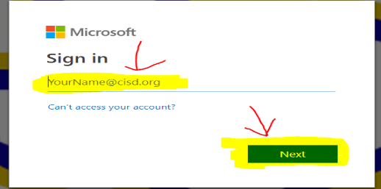
- You will then have to sign in to your One Drive and then click next (It is your school email address)

- You will then be sent to the CISD Page and have to put in your password (same password you use to login to your computer) and then click Sign In 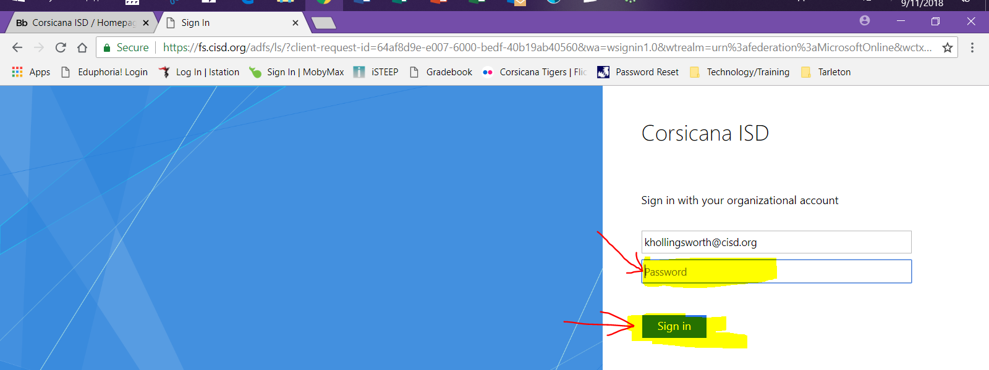
- The you will click on Shared 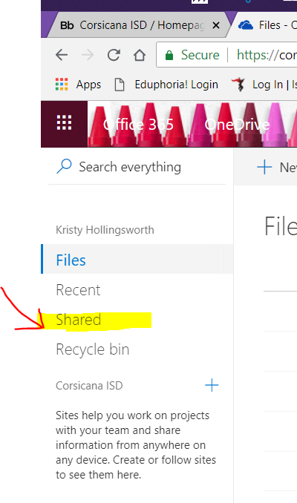
- Make sure it says shared with me and you should see the file you were sent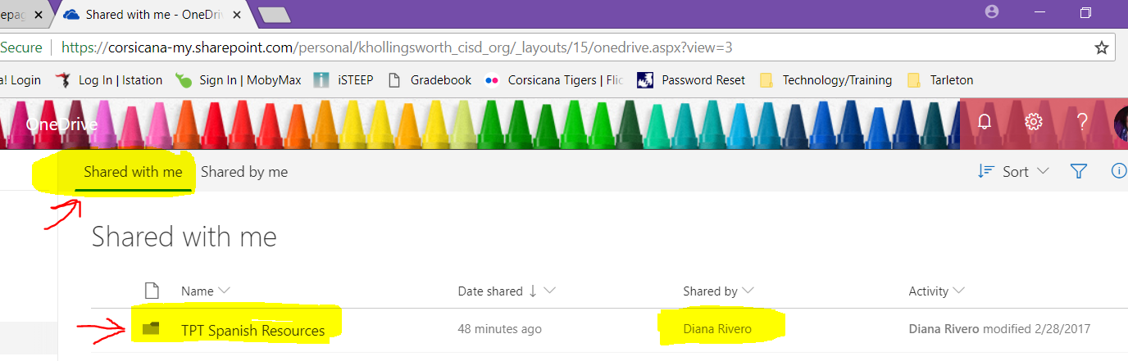
- Click on the File and it will open a new tab with all the files in it and you can open whichever one you need 